My health and wellbeing in prison and beyond (women) Part 2

Unit 2

Let’s talk about
mental health





Contents

Unit 2 Let’s talk about mental health: teachers’ notes

Unit 2 Let’s talk about mental health: learner resources

Unit 2 Let’s talk about mental health: answers and transcript

Video: Prison_Listener.mp4

Copyright - please read
All the materials on these pages are free for you to download and copy for educational use only in your establishment. You may not redistribute, sell or place these materials on any other website without written permission from the British Council. If you have any questions about the use of these materials please email us at: esolnexus@britishcouncil.org

Overview
This unit focuses on the difficult and sensitive issues of mental health in prison. The prison Reform Trust reports that 70% of women in prison suffer from two or more mental health issues. ESOL learners have the additional stress of perhaps not fully understanding procedures and processes that have caused them to be in prison and that exist in a prison environment. Women feel the stress of leaving children and families behind them. Many lose their children to foster or adoption services while in prison.
The session teaches basic vocabulary for mental health issues, gives practice in speaking and listening skills to support learners to talk about mental health and their feelings and respond to written texts. The unit supports reading and writing skills including building verb/word families adjective work, reading for meaning and writing using writing frames.
Be sensitive about how much or how little learners wish to share of their personal experiences and feelings. Some of the examples in the resources might arouse strong feelings so try to focus more on the language structures than the content if necessary.

Level: Entry level 1-3 / National 2 – 4 / CEFR A1 - B1

Time: 90+ minutes. Timings are flexible and teachers can break down the units into smaller chunks of learning and build in revision as required.

Aims
- Access the vocabulary to talk about personal issues that affect many prisoners
- Recognise and use vocabulary related to anxiety and depression
Objectives
For all learners:
- To introduce vocabulary to talk about mental health and wellbeing at an appropriate level.
- To talk about and share information related to stress, anxiety and depression.
- To provide opportunity to listen to the vocabulary in context
- To ask questions about accessing services and to give advice

For learners at Entry 1 and 2
- To understand and read key words and phrases relating to mental health.
- To write words and phrases about mental health.

For learners at Entry 3
- To use written texts to contextualise vocabulary
- To listen for detail and write sentences and text
- To give advice and make relevant responses about mental health

Preparation
You will need:
Video Prison_Listener.mp4
Resources 1a – lower level wordle ( a computer generated word picture) or 1b higher level wordle
Resources 2a and 2b one copy per learner. Choose according to your learners’ levels.
Resource 3a and 3b-one per pair of learners cut into cards and handed out according to level.
Resource 4 – one per pair of learners or displayed for a whole class activity
Resource 5a and 5b – one per learner according to level
Resource 6 - one per learner, cut up.
Resources 7 and 8 - one per pair.
Resource 9 – one per pair or small group of 3 or 4
Resource 10 - one per pair of learners cut into cards

Vocabulary books / personal dictionaries
Leaflets on mental health services, the chaplaincy, Listener scheme, range of activities and any other support available.
Teacher reference: printed video script included

Suggested Procedure
Opener: pre-teach the key vocabulary for the unit. (10 – 15 minutes)
All learners
- Distribute resource 1a and b, the vocabulary wordle (a computer generated word picture) per pair of learners. There are two levels – 1a being appropriate for learners at around E2/N3 and 1b at E3/N4.
- Arrange learners in ability groups and distribute the correct level wordle or choose one wordle that suits your learners best.
- For lower level learners, select four or five words to focus on. Pre-teach using mime and write the words on the board. Drill pronunciation.
- Recap vowels and consonants. Then distribute resource
- Learners with limited literacy could work in pairs to complete the first (vowel) activity, while those with stronger literacy skills could attempt to complete all the gap fill words on resource 2a and more advanced learners complete 2b.
- Recap pronunciation of the vocabulary with learners using the wordless before playing a pronunciation game.
- Pronunciation game: use the word cards in resource 3a and b for small group work. Hand out a set of 3a or b according to level.
- Ask learners to place the words face and take turns to pick a card and say the word aloud. If they try this they get 1 point. If they decide to pass it to another learner to say aloud, that learner gets 2 points. You will need to set a target for the winning number of points and this will depend on the number of learners in the group.
Extension activity for higher level learners
- Identify the word families and sort them into nouns and adjectives. Learners should add new words to their vocabulary books / personal dictionaries
stress stressed / anxious anxiety / worry worried / depressed depressing / relaxed relaxing / tense tension

Activity 1 Questioning (10 minutes)
- Distribute resource 4 and tell learners to look at pictures on display it on the interactive white board (IWB). .
- Point to a picture and ask learners to identify whether the person is happy, relaxed, sad, depressed, stressed or anxious. There are lots of different possible answers but check for learners’ basic understanding of the concepts.
- Elicit and drill Do you think..? questions with learners. For example: Do you think she is sad? Is she sad?
- Practise the answers ‘Yes, I do./ No I don’t....’
- Get learners to ask you the questions
- Ask them to work in pairs and question each other.

Activity 2 Reading about mental health in prison (15 minutes)
- Write ‘mental health’ on the whiteboard and ask learners to say words they think might be linked to the words mental health
- This is a good opportunity for eliciting meaning from vocabulary in the warmer. You may get some slang or less acceptable words so use this as an opener to the subject.
- Elicit that looking after your mind and mental health is as important as looking after your body.
- Distribute appropriate version of resource 5 ‘Let’s talk about Mental Health’, with a reading exercise followed by a writing exercise, to learners according to level.
- Ask learners in pairs to read and retell some of the detail of the leaflet to their partner.
You could use the text for a paired reading activity described below.

Additional activity:
Paired reading
- Pair two learners of different reading abilities together (A being the stronger reader and B the weaker reader)
- The pair talk about the text – what is it about? What kind of a text is it – a leaflet, story?
- Pairs start by reading the text together. They could pause every couple of sentences in turn stopping to discuss what they have read. They may discuss the words and phrases and try to work out the meaning of any that are unfamiliar.
- They read together with A matching B’s pace. When B feels confident to read independently she signals to A to stop reading and continues to read alone.
- Reader A does not correct immediately when B makes an error or hesitates on a word, but waits for at least 5 seconds for B to self-correct before intervening
- Where B does not self-correct a word, A says the word while pointing to it and asks B to repeat it.
- The pair continue to read together till B wants to continue independently and gives A a non-verbal signal as before.
- At the end they praise and thank each other.

- Learners to complete the gap fill exercise and peer check for accuracy.
Activity 3 Representing feelings (10 minutes)
- Explore what learners understand by depressed, stressed and anxious. Cut up resource 6 to help with this and use a short mix and match activity.
- Ask learners to try and draw a picture that suggests 1) stress, 2) depression and 3) anxiety using colours and simple drawings. (This is part of the reflect – action approach to learning. You can find out more at www.reflect-action.org).
- Explain that this is not about drawing but representing; give learners an example such as drawing a dark cloud for depression. .
- Accept and encourage verbal contributions about learners’ concepts about stress, depression and / or anxiety.

Activity 4 Writing sentences using a format. (15 minutes) (60)
- Distribute resource 7. These are 4 case studies of learners in prison who have problems. Tell learners to spend a few minutes to read through the case study cards or read them one at a time to them.
- Focus learners attention on one case study at a time
- Ask learners to respond to the following questions
How is this person feeling?
What is this person’s problem?
- Support learners to develop a case study profile using the blank writing frame at the end of resource 7 using one of the profiles given. Depending on their level of ability they could write a word or phrase, with the most proficient writing in sentences.
- Extension activity - if reading practice is needed, ask for volunteers to read a case study out to the whole class or to a small group of three or four. .
Activity 4 Listening to a Listener (15 – 20 minutes)
- Ask learners who they speak to if they are feeling down. Elicit as many suggestions and write them on the board. Ask ‘who else’ until all possibilities are exhausted.
- If Listeners are not mentioned ask them if they have heard of the service.
- Tell the learners they will watch and listen to a video about being a Listener in prison.
- Show the video straight through, then again stopping after each section to check learners have understood.
- Use question and answer to check understanding about the role of the Listener in prison.
- Personalise this: do learners know who the Listeners are in prison or on their wing? Share information between learners.
- Group learners in mixed ability trios and ask them to recall three things about being a Listener and report these back to their group. Monitor and note what learners at lower levels say.
- Nominate learners to report one thing back to the whole class. Start with closed questions for the lower level learners e.g. ‘What do Listeners wear? What is the name of the Listener on your wing?’
- Next widen this out to challenge higher level learners. Ask for other information telling them not to repeat anything that has been said. You could ask specific questions or just say ‘What else (do you know)?’.
- Distribute resource 8 - becoming a Listener quiz to each pair of learners. Ask learners to read the questions first. Play the video again. Ask learners to take it in turns to ask each other each question and tick the correct answers in the quiz.

Activity 5 Design a poster (15 – 20 minutes)

- Tell the learners they are going to design a poster giving some information about the Listener service.
- Either distribute resource 9 or display it on the IWB. Look at it together. Elicit what sort of information they should include. Draw attention to the layout.
- Ask learners to work in pairs (or threes) for this activity if you consider it appropriate for your class. Match more able learners with less able
Differentiate learning by
- Learners at lower levels to write one phrase or simple sentence per section on resource 9, using capital letters and a full stop where needed.
- More advanced learners to write two sentences per section.
- Assist and encourage self-correction as you monitor the activity.
- After the activity, ask learners to circulate the room and look at other learners’ posters.
- Ask questions to gain information listen and respond: ‘do you know any Listeners? How would you contact a Listener in this prison? Who else can help with mental health problems in prison?’ Through this process elicit options open to learners in prison to gain help and support with their mental health.
- Write a list of all sources of help – e.g. Listener, counsellor, doctor, nurse, chaplains.
- Draw attention to any information leaflets you have brought.

Activity 6 Giving advice (10 – 20 minutes)
- This activity considers the difference between giving advice and telling someone what to do.
- Play the ‘Simon says‘ game to demonstrate and drill the imperative form. Get learners to stand up, sit down, and other simple actions. Keep it lively to lift the mood after the sombre topics they have looked at.
- Pause the game and write up some of the commands on the board. Either elicit from the learners that this is the form of the verb you use to tell someone to do something if you have already covered the imperative, or teach it.
- Start the game again but this time preface your commands with ‘You could sit down..’ ‘Why don’t you ..’ ‘You should..’ in a gentler tone.
- Stop and elicit from them how the second set of commands differed from the first. Find out if they noticed the difference in tone.
- Hand out the cut outs from resource 10
- Ask learners to work in pairs to match text to image
- Check they have matched the phrases to the pictures correctly.
- Ask learners what they would advise someone to help them relax.
- Write up or display the phrases you used in the second part of the ‘Simon says..’ game eg
  - You should.....
  - You could.....
  - Why don’t you
  - Elicit others from learners if appropriate.
- Ask the learners to work in pairs and using the picture cards from resource 10 and to take it in turns to show a card and give advice about how to relax using the activity in the picture.

Additional / extension activities
- Put this exercise on the whiteboard and ask learners to rearrange the words to make sentences about giving advice. They need to add punctuation.

- you going to why try don’t gym the
- television you relax could watching by
- could the library you join
- fruit You more vegetables eat should and
- more do You exercise try could to
- to friend chat why have not a

- Ask learners to share any other activities they do to relax in prison. Write these on the whiteboard. Use these to extend the opportunity to give advice.
- Use the language of frequency with resource 10 (twice a week, once a day, every day) to introduce expressions of frequency. Write some expressions down on the whiteboard / flipchart – or prepared on card prior to class – and ask learners to order the expressions from most to least frequent.
- Use selected pictures from resource 10 or the leaflets as prompts for learners to receive advice, for example: How often should I go to the gym? When is the library open? When can I go to use the phone? When can I speak to the chaplain?
Cooler (5 minutes)
- Ask each learner to share one new thing they are going to do to help them relax as a result of the session.
- Write these down as a class list. You could add the time when they are going to do it e.g. Silvana is going to try a yoga class on Monday.
- Make sure you ask them to report back at a following session. You could take the opportunity to practise the past tense and functions such as giving opinions.
Further activities:
The Samaritans have produced DVDs for their Listener scheme in prisons. These were filmed in prisons and include prisoners (male or female on separate videos) talking about their experience. Ask the scheme coordinator in your prison to visit your class and show the DVD. Work with your class to decide on questions to ask the visitor and design further speaking and listening activities based on the video.

Resource 1a Wordle

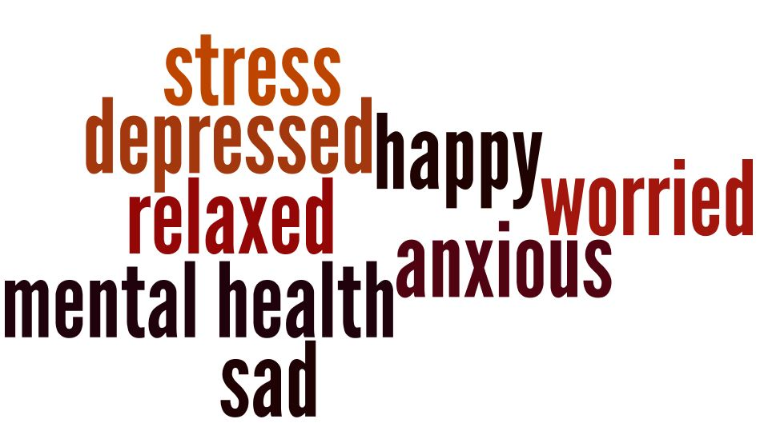

Resource 1b Wordle

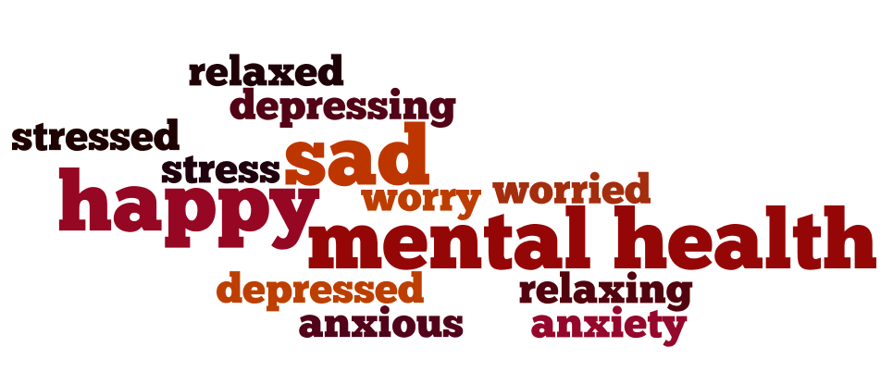

Resource 2a Fill in the missing letters
- All the vowels are missing from these words about m_nt_l h_ _lth
str_ss
_nx_ _s
a e i o u
w_rr_ _ d
d_pr_ss_d
r_l_x_d
h_ppy
s_d

- All the consonants are missing from these words about –e_ _ a_ _ea _ _
_e_a_e_
b c d f g h j k l m n p q r s t v w x y z
a_ _ iou_
___e_ _
_o_ _ie_
_a_
_e_ _e_ _e _
_a__y

- A mix of letters are missing from these words about m_n_a_l h_a_t_
s_r_s_
a_x_o_s
w_r_i_d
d_p _e_s_d
r_l_x_d
h_p_y
s_d

Resource 2b Missing letters
- Fill in the vowels missing from these words about m_nt_l h__lth
_nx_ _ty
d– pr_ ss _ ng
str_ss
_nx_ _ _s
w_rr_ _ _
r –l_x_ng
d_pr_ss_d
r_l_x_d
h_ppy
w _ rry

- All the consonants are missing from these words about _ e_ _ a_ _ea_ _
_e_a_e_
a_ _ iou_
_ _ e_ _
_nx _ _ ty
_o_ _ie_
_e_ _e_ _e –
_a_ _ y
_e_ _e _ _ e_

- A mix of letters are missing from these words about m_n_a_l h_a_t_
s_r_s_
a_x_o_s
w_r_i_d
d_p _e_s_d
r_l_x_d
Resource 3a Word cards

stress | anxious | worried
happy | sad | health
depressed | relaxed | mental

Resource 3b Word cards

stress | anxious | stressed
worry | worried | depressed
sad | relaxed | relaxing
depressing | anxiety | happy

Resource 4 Good and bad feelings

Who is sad, happy, depressed, relaxed, worried, and anxious?

Is she _____________________?







Resource 5a Reading
Let’s talk about mental health

Mental health is about how you feel in your mind. It is part of being healthy.
Sometimes you feel good. You feel happy and relaxed.
Sometimes you don’t feel good. You feel sad, anxious or stressed.
Many people in prison feel sad, anxious and depressed and may have problems with their mental health.
If you feel sad, worried or stressed most of the time you may need help from other people in the prison.
You may know someone who feels anxious, stressed or worried and who needs some help.

Resource 5a Fill in the gaps

Mental ___________ is about how you feel in your mind. It is part of being healthy.
Sometimes you feel good. You feel ___________ and relaxed.
Sometimes you don’t feel good. You feel sad, ____________ or stressed.
Many people in prison feel __________, anxious and depressed and may have problems with their ___________ health.
If you feel sad, ________ or stressed, you may need help from other people in the prison.
You may know someone who feels_______ _, stressed or ________and who needs some help.

Resource 5b Reading
Let’s talk about Mental Health

Mental health is about how you feel in your mind. It is part of being healthy.
Sometimes you feel good. You feel happy and relaxed.
Sometimes you don’t feel good. You feel sad, anxious or stressed.
Many people in prison feel sad, anxious and depressed and may have problems with their mental health.
Being in prison is a difficult time. If your mind is not feeling good you may
- lose weight
- sleep badly
- cry
- feel anxious and worried a lot of the time
If you feel sad, worried or stressed most of the time you may need help from other people in the prison.
You may know someone who feels anxious, stressed or worried and who needs some help.

Resource 5b Look again carefully at the article and find the missing words in the text below and fill the gaps with the correct spelling.

______ health is about how you feel in your ______ . It is part of being healthy.
Sometimes you feel good. You feel _____ and _______.
Sometimes you don’t feel good. You feel sad, _______ or________.
Many people in prison feel sad, _______ and _________ and may have problems with their mental __________..
Being in prison is a difficult time. If your mind is not feeling good you may
- lose weight
- sleep badly
- cry
- feel ________ and worried a lot of the time
If you feel sad, _______ or stressed most of the time you may need help from other people in the prison.
You may know someone who feels anxious, ________ or worried and who needs some help.

Resource 6 Difficult feelings

word | meaning
stress | Poppi finds prison life very difficult. She is very worried about lots of things in her life and feels she can’t cope. Poppi is stressed
anxious | Tama can’t relax. She often feels frightened. She is tense all the time. Tama is anxious.
depressed | Cara is feeling sad and upset. She has been sad and upset for a long time. Cara is feeling  depressed.
worried | Filipa has lots of difficult things going on in her life that she needs to sort out. She is often worried.

Resource 7 How is she feeling?
Ariana is 22. She will leave prison next month. She doesn’t have a place to live. She is worried about getting money. She doesn’t have a job to go to. She is worried about finding a place to live. She is feeling very anxious about leaving prison. She is worried about her life on the out.
What is her problem?
How is she feeling?

Cara is in prison for five years. She feels depressed and very sad. She misses her little girl, Eva. She misses her family. She cries a lot in her cell. She doesn’t have any friends in prison. The prison officers are kind to her but she wants to be out of prison.
What is her problem?
How is she feeling?

Kayla is in HMP Flinthill. She has been in there for one week. She came from another prison. Everything is new to her. It is very stressful.
She is worried about making new friends and starting new work in the workshop. She doesn’t have good English skills..
What is her problem?
How is she feeling?

Leah has been in prison for eight months. She is worried she will be deported and sent back to Albania very soon. Her partner lives in the UK. She wants to stay here. She is going to court next week. She feels very anxious. She can’t sleep or eat

What is her problem?
How is she feeling?

Resource 7 continued



Maya, 28, has 4 children in foster care.
She has just moved prison and is too far away for children to visit.

What is ................’s story

What is her problem?
How is she feeling?


Tina, 26, 15 years to do in prison
Her mother died recently. Her father is ill.

Resource 8 Quiz

- How did John find out about becoming a Listener? Tick two answers
- Read about it in the prison newsletter
- Saw a poster on the wing
- Heard it from a neighbour
- Someone told him about it in the workshop

- How did John apply to become a Listener? Tick one answer
- Asked his prison officer
- Got a form from the library
- Completed an application form

- Did John get training to be a Listener? Tick one answer
- Yes
- No

- What sort of problems does John hear about as a Listener? Tick two answers
- prison food
- drugs
- visiting times
- deportation

Resource 9 Design a poster
What skills do you need?
*
*
*
How do you become a Listener?
*
*
*
*
What does a Listener do?
*
*
*
*

Become a Listener
We need more Listeners in our prison
Let’s tell you more

Resource 10 Healthy activities

Do something you enjoy like watching some TV | 
Take exercise – go to the gym or work out in your cell. | 
Talk to family and friends on the phone | 
Try and eat fruit, vegetables and salad when you can | 
Find out about relaxation from healthcare | 
Go to the library and choose a book to read | 

Answers

Resource 2a Missing letters

a) missing vowels | b) missing consonants | c) missing letters
stress  anxious  worried  depressed  happy  sad | relaxed  anxious  worried  depressed  happy | stress  anxious  worried  depressed  relaxed  happy  sad

Resource 2b
a) missing vowels | b) missing consonants | c) missing letters
anxiety  depressing  stress  anxious  worried  relaxing  depressed  relaxed  happy  sad  worry | relaxed  anxious  stress  anxiety  worried  sad  depressed  happy | stress  anxious  worried  depressed  relaxed

Resource 5a
Mental health is about how you feel in your mind. It is part of being healthy.
Sometimes you feel good. You feel _happy_ and relaxed.
Sometimes you don’t feel good. You feel sad, anxious or stressed.
Many people in prison feel sad, anxious and depressed and may have problems with their mental health.
If you feel sad, anxious or stressed, you may need help from other people in the prison.
You may know someone who feels anxious, stressed or sad and who needs some help.

Resource 5b

Mental health is about how you feel in your mind . It is part of being healthy.
Sometimes you feel good. You feel happy and relaxed.
Sometimes you don’t feel good. You feel sad, anxious or stressed.
Many people in prison feel sad, anxious and depressed and may have problems with their mental health.
Being in prison is a difficult time. If your mind is not feeling good you may
- lose weight
- sleep badly
- cry
- feel anxious and worried a lot of the time
If you feel sad, worried or stressed most of the time you may need help from other people in the prison.
You may know someone who feels anxious, stressed or worried and who needs some help.

Resource 8 Quiz
1 How did John find out about becoming a listener? Tick 2 answers
- Saw a poster on the wing v
- Heard it from a neighbour v
2 How did John apply to become a listener? Tick one answer
- Completed an application form v
3. Did John get training to be a listener? Tick one answer
- Yes
4. What sort of problems does John hear about as a listener? Tick 2 answers
- drugs v
- deportation v

Becoming a Listener - transcript for reference
Interviewer: Hello John. Thank you for talking to us today about being a Listener inside prison. You’ve been a Listener for three years. Can you tell us – how did you find out about being a Listener?
John: There are different ways to find out. Sometimes they put up notices, you know, posters, on the wings – asking for Listeners. I heard about it from a neighbour on my wing. He’s a Listener and talked to me about it. I thought it sounded good and I wanted to do it.
Interviewer: Can you tell us more about why you wanted to become a Listener?
John: He told me that you need to have special qualities to be a Listener. That’s what’s inside you – what you are like. You never know what people will talk to you about, so you need to sit and listen and don’t judge them. My opinion is not important – I’m just there to listen, not to say if something is good or bad. The men know that they can talk to me and they trust me. And it’s important they know that I won’t tell anyone what I hear – it is all confidential – completely secret. If I’m a Listener, I can’t tell anyone what I hear.
Interviewer: Yes, that’s important that the men know it is confidential and no-one else will know about the conversation.
Can you tell us how you apply to be a Listener?
John: First I completed an application form. I sent the form to the Safer Custody Department and they gave it to Security. Then I had a face to face interview. I did well in that!
Interviewer: Did you have any training?
John: Yes, it was excellent. The Samaritans come in and train us. We did role plays – like acting the things people say when they talk about their problems. And we watched some videos about how the Samaritans work. We also went to some classes. It took about three weeks.
Interviewer: Can you tell us about the problems people talk about with you?
John: Every problem! Lots of prisoners talk about problems they have with drugs. The men also come and talk when they are feeling bad. Feeling suicidal – like they want to kill themselves. Or feeling frightened. Lots of men feel very stressed in here and lonely. Sometimes they might just come and ask for a cigarette. And you get people coming when they are grieving – you know someone has died. It’s very difficult for them.
Interviewer: Can you tell us about problems people from other countries talk about?
John: Most of them are scared of being deported and leaving their families behind. Some are waiting to go, but there are delays. For others, their families are a long way from here – that is a kind of grieving too.
Interviewer: Have you changed since you became a Listener?
John: My communication skills have improved a lot. I find it really easy now to listen to people and really hear what they say and not judge them.
Interviewer: How do you think it helps people to go to a Listener?
John: It’s important for them to know that there is always someone there for them – just to listen and help them deal with their problems.
People think it’s only the drug-addicts who call us but that’s not true. I have seen some tough men, always talking – but then when they are locked up – on their own – they become very quiet. It’s hard. That’s when they call for a Listener.

